

JOB DESCRIPTION

POST TITLE: SENIOR LICENSING OFFICER

POST NUMBER: PH12

GRADE: H

RESPONSIBLE TO: TEAM LEADER (COMMERCIAL TEAM)

RESPONSIBLE FOR: Licensing Assistants

LIAISON WITH: Other officers and internal client services, members of public and Members of the Council. Other Mid Devon Officers, including but not limited to, Legal, Member Services, Planning Enforcement, Building Control. Other Local Authority Officers, Government bodies and enforcement agencies, Safety advisory Group (SAG) partners, representatives of local and national businesses.

KEY CORPORATE ACCOUNTABILITIES:

The efficient and effective delivery of the statutory Licensing functions of the Council. To act as the escalation point for Licensing matters and make decisions on referral to sub-committee both within and outside of the available policies.

Support the formulation of policies and strategies and ensure the effective delivery of the Licensing service within Public Health and Housing Options where they are relevant to licensable activities.

To advise and guide the Licensing and Regulatory committees, Sub-Committees thereof and Full Council in the delivery of the statutory Licensing policy framework.

Provide day to day line management of the Licensing Assistants ensuring the delivery of an effective and efficient licensing service.

KEY SERVICE ACCOUNTABILITIES:

- To work as a Senior Officer and implement the delivery of the Council’s statutory licensing functions that are the responsibility of the Public Health and Housing Options.

- To ensure that those services are provided in an efficient and effective manner and meet the requirements of the national requirements, guidelines and strategies through the development of operational practices. All work to be carried out in accordance with the Council’s agreed policies and practices, statutory obligations, service standards and quality criteria.

- Support the formulation, implementation and delivery of service policies, service fees, objectives and work priorities to ensure that statutory obligations, targets and performance indicators are met.

- To provide day to day line management of the Licensing Assistants, leading staff to achieve high performance and effective operational delivery, including developing and improving staff capability, motivating and mentoring them to better meet the current and future requirements of the service. Carrying out performance monitoring and reviews and setting objectives.

- Be responsible for allocating and prioritising the workload of Regulatory Officers.

- To be directly involved, as necessary with the processing of applications for all Licence types under the responsibility of the Council. To check and issue licenses, certificates and registrations in accordance with legislative requirements.

- To investigate complaints in relation to both Licence holders and where a Licence or authorisation is required but has not been sought.

- Carry out all required investigatory processes in accordance with PACE, RIPA and other relevant legislation.

- Initiate prosecutions, prepare detailed prosecution files and attend relevant court proceedings, committees, hearings and meetings when required.

- To work with internal and external partners to investigate and resolve complaints and issues as required. To develop and maintain working relationships with partner organisations to support with service delivery as required, including but not limited to; other Local Authority Licensing service leads, Devon Highways, Devon and Cornwall Police, Home Office Immigration, Trading Standards, Fire Service, RSPCA, APHA, responsible authorities.

- Processing appeals either by written representation or by representing the Licensing Authority at the Magistrates Court.

- To represent the Licensing Authority at the Magistrates Court when applying for warrants under the relevant legislation.

- To support the Team Leader with development of the team, devising and delivering training sessions on all relevant areas of Licensing and cascade training where applicable.

- Prepare and present reports to the Licensing and Regulatory Committee in respect of all the areas for which the Council is the licensing / registration authority, making lawful recommendations where appropriate.

- Support the setting of licensing fees and review them in accordance with both legislative requirements and case law to ensure legal compliance.

- To carry out appropriate enquiries, respond to complaints and where necessary prepare evidence in respect of breaches of appropriate licensing legislation and to attend Courts of Law/Hearings to give evidence where required.

- To ensure a high level of specialist knowledge in the areas of Licensing. Actively maintain professional competence and progress post specific learning and development, through self-study and the range of training and mentoring opportunities available. To continually develop skills and abilities within the role.

- To manage a high volume of licensing processes with the ability to work well under pressure and to deadlines.

- Assist in the preparation of all relevant statutory and non-statutory returns.

- To attend SAG and advise event organisers and land owners on Licensing elements as required under the SAG terms of reference. To deputise for the SAG chair as required.

- To represent Mid Devon District Council or make representation on working groups and at liaison meetings with other external bodies and organisations.

- Work outside the normal hours of work as and when required for the proper execution of the Council’s duties.

- Assist the Team Leader (Commercial Team) and the Operations Manager for Public Health and Housing Options in the overall management of the Service. To deputise for the Team Leader (Commercial Team) or other officers as directed.

- To undertake such other duties as may be required in respect of licensing and related work.

OTHER DUTIES:

In order to deliver services effectively, a degree of flexibility is needed and the postholder may be required to perform work not specifically referred to above. Such duties, however, should not normally exceed those expected of an employee at that grade.

HEALTH AND SAFETY:

The Council has a health and safety policy, which outlines its responsibilities as an employer, and the responsibilities of its employees in respect of health and safety. All employees need to be aware of this policy and comply with its content.

RISK MANAGEMENT:

All employees need to have an awareness of risk management and are responsible for ensuring that they manage risk effectively in their job and report hazards and risk to their Head of Service of Senior Manager.

DATA PROTECTION:

It is the responsibility of the Postholder to ensure that the section’s requirements for compliance with the Data Protection legislation are met.

SAFEGUARDING CHILDREN AND ADULTS AT RISK:

The Council has a Safeguarding Policy, which outlines its responsibilities and the responsibilities of its employees. All employees need to be aware of this Policy and comply with the contents.

When considering the duties of this role as part of the most recent Job Evaluation (JE), a decision was reached using the government DBS Tool that this role is required to hold a Basic DBS level check. The basis on which this form of DBS is renewed is explained further within our DBS policy.

Date: March 2025

MID DEVON DISTRICT COUNCIL’S REQUIRED COMPETENCIES

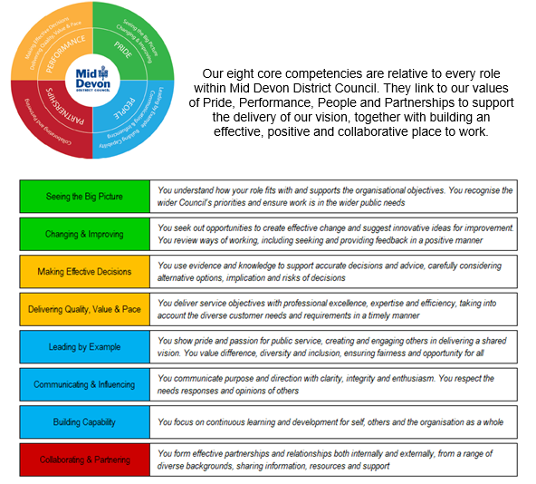

PERSON SPECIFICATION

Senior Officer (Licensing)

 | ESSENTIAL | DESIRABLE
Qualifications  and  Experience | - Relevant Degree or Higher Diploma  - Certificate in Licensing Law or Full Membership of Institute of Licensing  - Level 3 award for animal inspectors, or willingness to work towards  - Demonstrable significant experience in a similar Licensing role  - Experience of Licensing hearings | - Supplementary qualifications in other relevant areas  - A relevant management qualification at level 5 or above
Knowledge and  Expertise | - Significant knowledge and experience in licensing statutory functions  - Knowledge of relevant licensing legislation | - Evidence of Continuing Professional Development  - Evidence of management experience  - Proven record of continuous change and improvement
Skills | - The ability to manage staff and allocate workloads  - The ability to create solutions, policies and strategies to address issues  - Excellent written, verbal communication and interpersonal skills with the ability to engage at all levels  - Numerate and an ability to critically evaluate and present information  - Training and motivational skills  - Competent in Microsoft applications (Word, Outlook, Excel, etc.) | - Experience of developing and completing initiatives independently and in partnership with other agencies  - The ability to understand and implement budgets  - Experience of fee setting  - Experience of IDOX Lalpac licensing management system
Personal Attributes | - The ability to handle difficult situations within the working environment  - Strong influencing and negotiation skills  - Demonstrate integrity at all times  - Confident, independent and assertive with a self-motivated approach and flexible attitude  - Communicates regularly and openly and able to handle pressure.  - Resilient and able to work to conflicting deadlines.  - Positive attitude to change Responsive and supportive to the team and colleagues. | - Strong team leader and ability to work under own initiative
Special Requirements | - To hold a full driving licence  - To undertake some work outside core hours

Post Ref: ES35
Date: November 2025

