Assistance dogs, private hire and taxis:
What you need to know

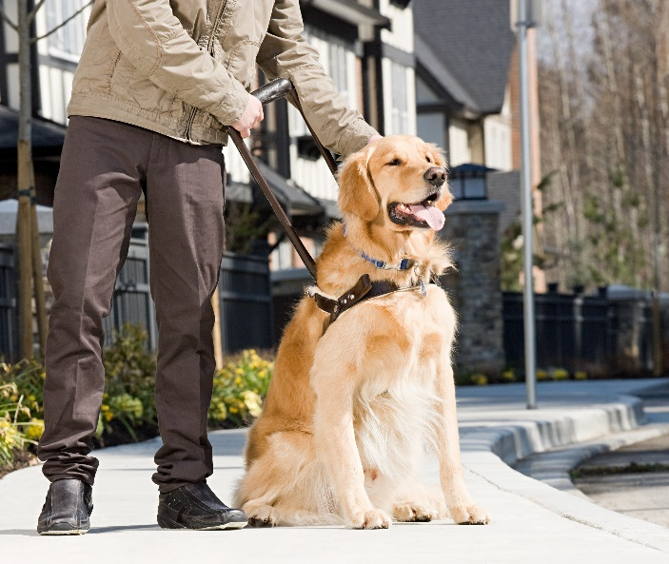

What is the most important thing for me to know and understand?
People who use assistance dogs use them to aid their independence. They are working dogs and are better behaved than pet dogs. Most people are friendly and reasonable. So, all you need to do is ASK how you can best assist in helping them into your taxi with their assistance dog.

What is an assistance dog?
An assistance dog is a dog which provides help and support to a disabled person. These can include guide dogs, hearing dogs and support dogs.

Can I refuse an assistance dog?
No. The Equality Act 2010 is totally clear that no driver can refuse a dog on any grounds – cleanliness of the dog, does not like dogs, fear of dogs, cultural or religious reasons. A refusal leaves you open to investigation by Licensing which could result in the withdrawal of your license, or to a legal claim against you.

What is a medical exemption?
A medical exemption can be issued by the Licensing Authority if you have a genuine medical reason why you cannot have an assistance dog in your taxi. You need to display the exemption openly in your taxi.

Can I say where the assistance dog has to go in the taxi?
Legally no you cannot. Most assistance dog users like their dogs in the front with them. A smaller number prefer them in the back. Others are happy for their dog to go in the boot of an estate car. It is very unlikely anyone will allow their dog to go into a saloon boot. You can ask the owner where they would like their dog to go, but if they ask for somewhere you don’t agree with you cannot insist.

Can I ask to put a blanket under the dog to collect hairs?
Yes, you can ask. Some owners will agree, some will not. Again, you cannot insist. Blankets or towels are preferred to plastic sheets. Some assistance dog owners carry their own blankets with them.

Can I charge more for carrying an assistance dog?
No. There are no circumstances in which you can do this.

If I arrive for a booking and find someone has an assistance dog but not told me, can I not pick them up?
No. The owner is under no obligation to tell you. The law says you must still pick them up.

If I really don’t like dogs, can I insist the dog is kept away from me?
You can ask politely for this, but you must understand that it may not be possible for the owner to do this. Getting frustrated or angry with the owner will not help and only make the owner feel uncomfortable and unwanted in your taxi.

What assistance do I need to give to the person using the dog?
Although some people who are blind or partially sighted have mobile phones, they will not know what the colour of your car or registration is. So, if you know or see the person has a visual impairment, please get out of the car to offer them assistance. Some will want to take your arm, some will want you to take their arm, and some will not want any assistance. Ask the person if they want you to put their hand on the top of the door so they know where it is. Don’t assume the person knows which way to go or that they can tell you where they want to be dropped off. Most importantly just ask.

Accessibility
If you need this document in an alternative format, please email
info@pocklington-trust.org.uk or telephone 020 8995 0880.

About Sight Loss Councils
Sight Loss Councils are led by blind and partially sighted members. We tackle local issues and work with businesses and service providers to improve the accessibility of their services.
Email: info@sightlosscouncils.org.uk
Website: www.sightlosscouncils.org.uk
Facebook: @SightLossCouncils
Twitter: @SLCouncils

